

**Report on Employment - Data Analysis of Job Placement and Outcome Dataset**

This report provides brief overview of the dataset and its context (employment records, including job placements, housing status, and other relevant factors).

**Data Overview:**

* Total number of records: 1875
* Key columns analyzed: Placement Status, PIT Housing Status, Location (city, state), Starting Hourly Wage, etc.
* Data cleaning and preprocessing steps.

**Analysis and Findings:**

1. **Placement Status Distribution:**
   * Visualized the distribution of placement statuses.
   * Found that out of 1875 records:
     + Placed: 1124
     + Placed - Unidentified: 460
     + Other statuses (Sustained, Left job, etc.).

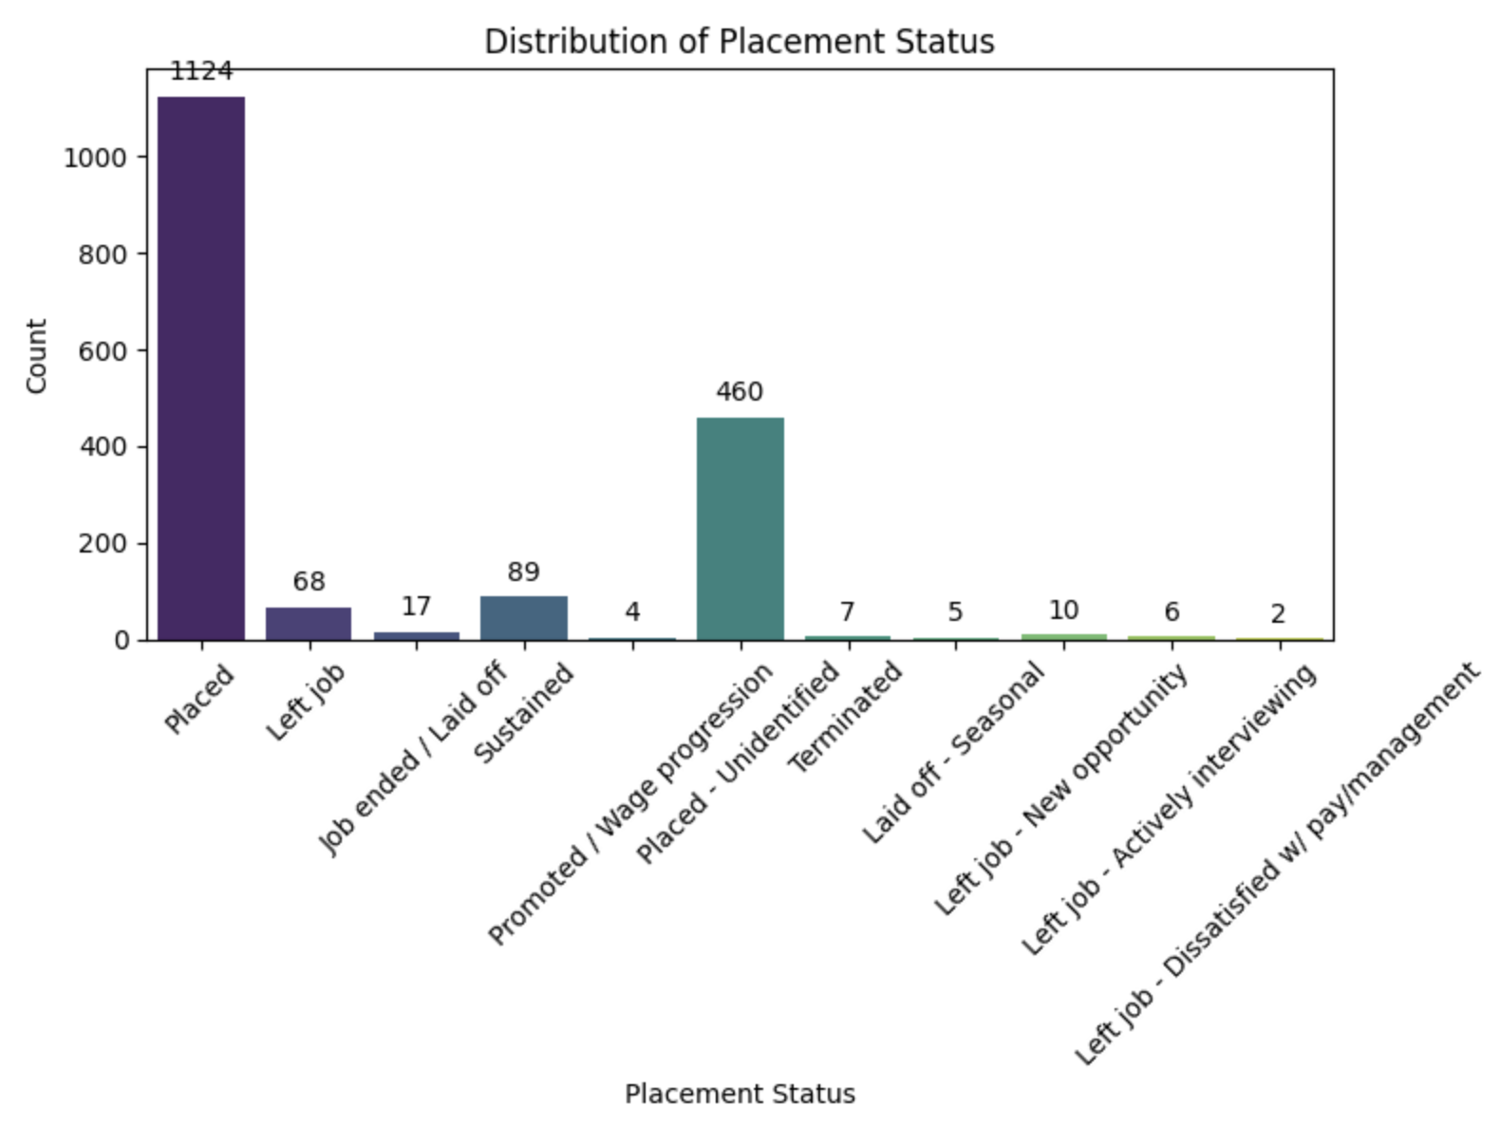

This graph shows the number of placements each year. Most placements occurred in recent years, with a noticeable increase in the 'Placed' category, indicating an upward trend in successful job placements.

* Placed: 1124
* Placed - Unidentified: 460
* Sustained: 89
* NaN: 83
* Left job: 68
* Job ended / Laid off: 17
* Left job - New opportunity: 10
* Terminated: 7
* Left job - Actively interviewing: 6
* Laid off - Seasonal: 5
* Promoted / Wage progression: 4
* Left job - Dissatisfied w/ pay/management: 2

**3. PIT Housing Status:**

* + Explored housing statuses of individuals.
  + Most common statuses include Rent (no subsidy), In a Shelter, Couch Surfing.
  + Portion missing (NaN values).

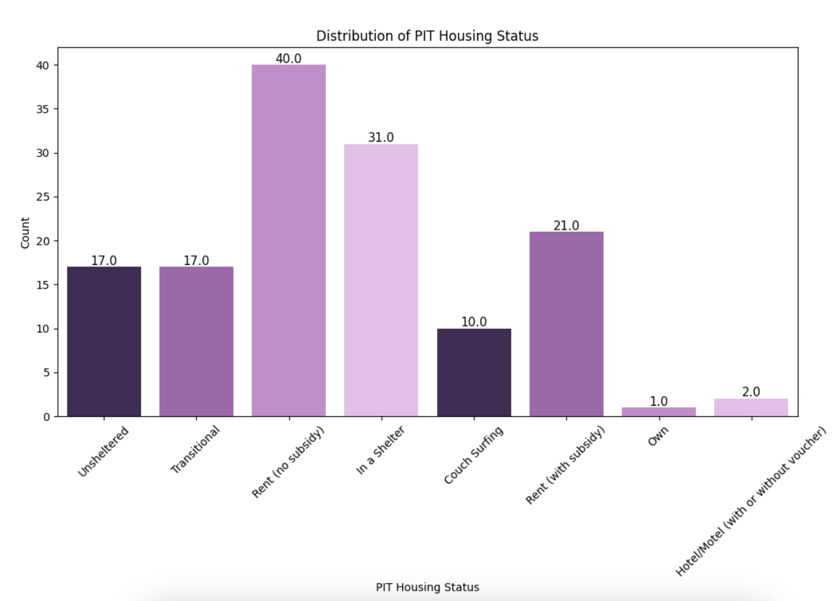

1. **Location Analysis:**
   * Analyzed locations (city, state) of employment.
   * Seattle, WA is the most frequent location, followed by Bellevue, WA and others.
   * Corrected inconsistencies in location data (e.g., Lynnwood, WA instead of Lynwood).

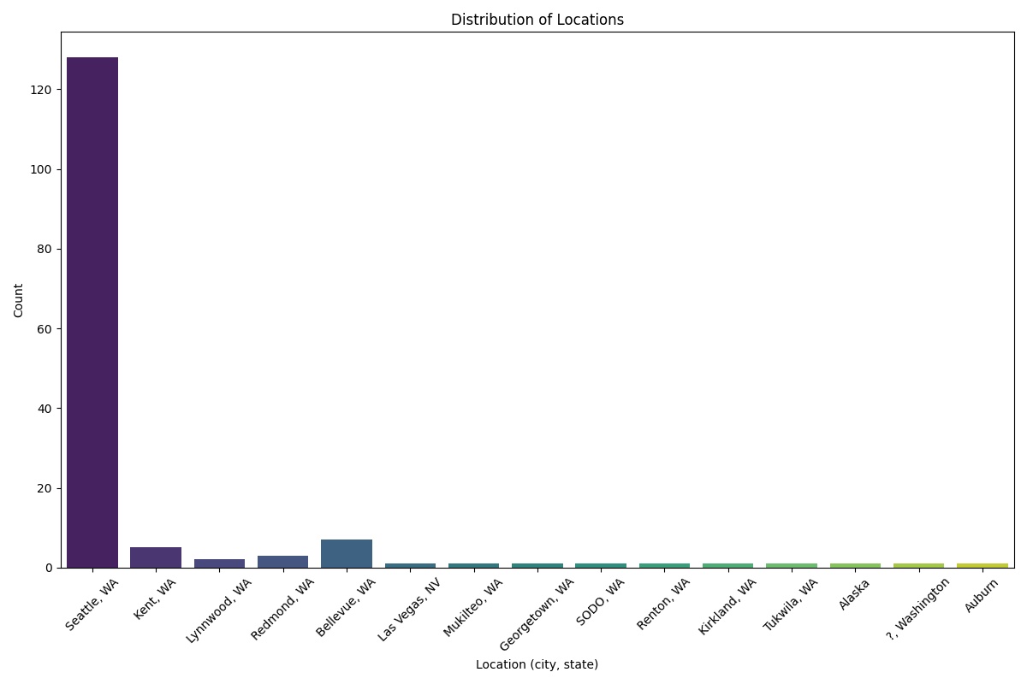

1. **Starting Hourly Wage:**
   * Distribution and analysis of starting hourly wages.
   * Range from $11.00 to $19.00 per hour.
   * Number of missing value (787 missing values), which impacted the depth of wage analysis.
2. **Training Analysis (Not Available):** If training information is available, we can analyze its impact on placement status.

**Insights:**

* **Geographical Distribution:** Seattle, WA emerged as the predominant location for employment. There are many regional disparities in job opportunities and housing support services, due to lack of data available.
* **Employment Stability:** There is very few subset of individuals experienced job transitions (e.g., Left job, Job ended / Laid off), but still we can suggest the need for ongoing support in career advancement and job retention strategies.

**Limitations:**

* **Data Completeness:** Missing data in housing status and wage information has limited the need of indepth insights.
* **Data Consistency:** Inconsistencies in location data (e.g., variations in city names) should be made effective with proper data cleaning efforts for accurate geographical analysis.

**Distribution of Hours Per Week**

The histogram reveals that most individuals work around 40 hours per week. There is a slight spread around this average, with some working more or fewer hours.

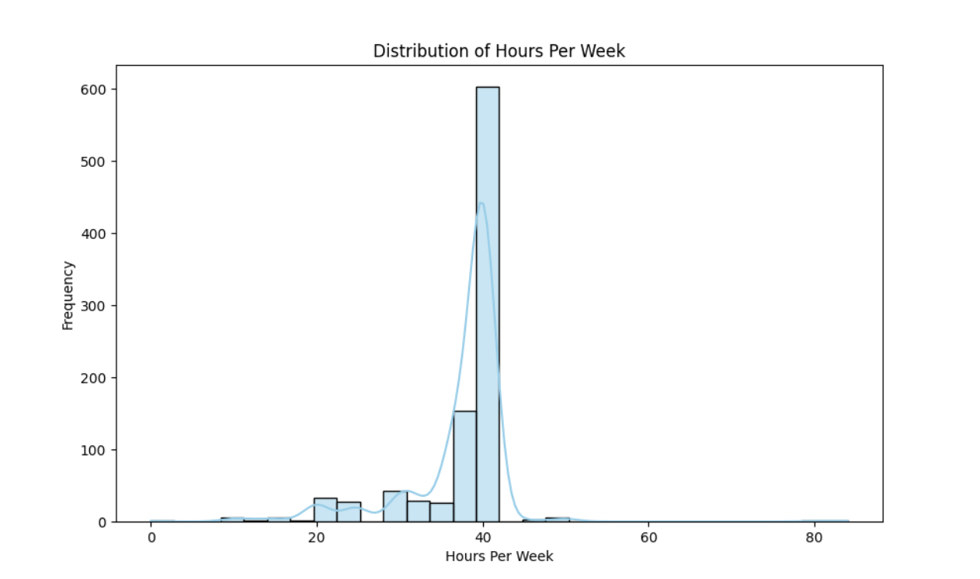

**Placement Status Count - Year Wise**

The bar chart shows the overall count of placements. The majority are 'Placed', suggesting a high success rate in job placements.

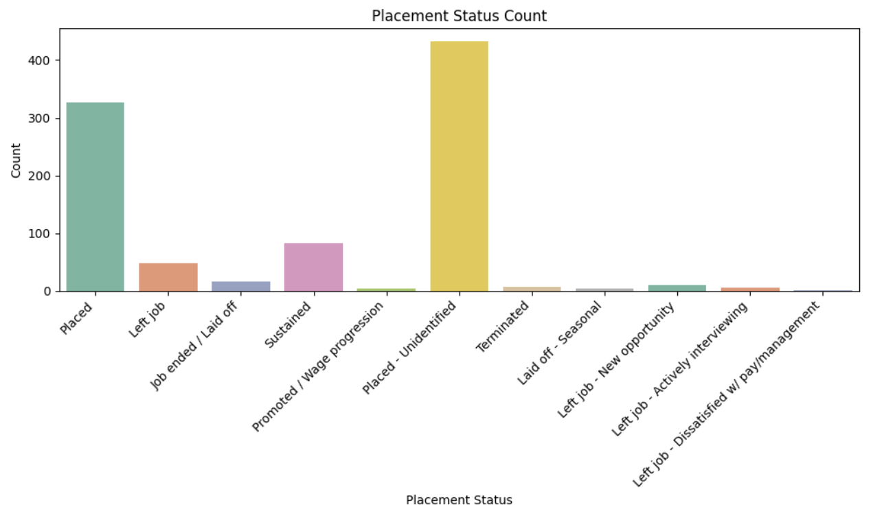

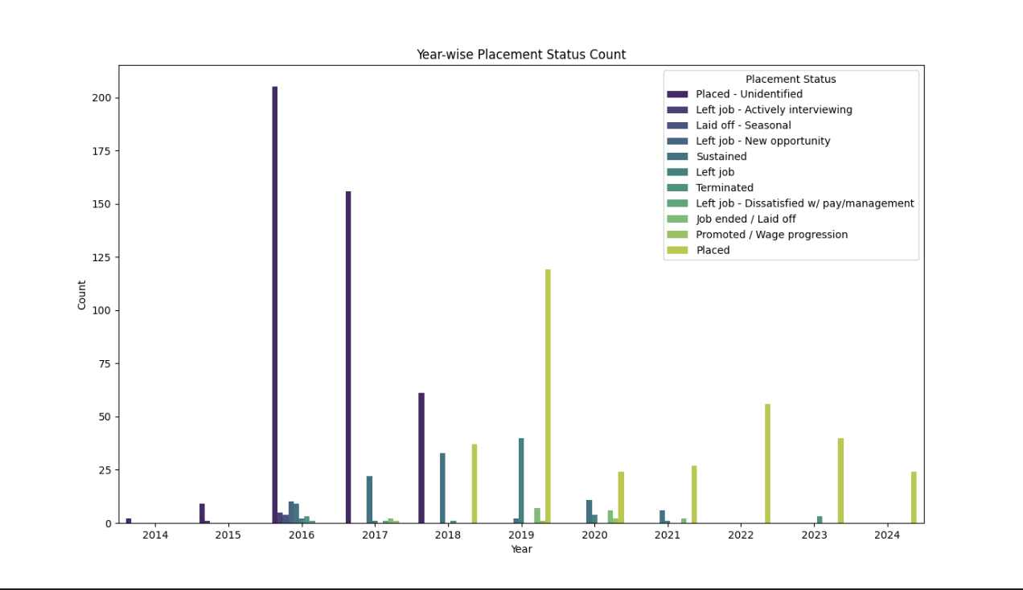

**Year-wise Average Hours Per Week**

The average hours per week have remained relatively stable over the years, with a slight increase in recent years.

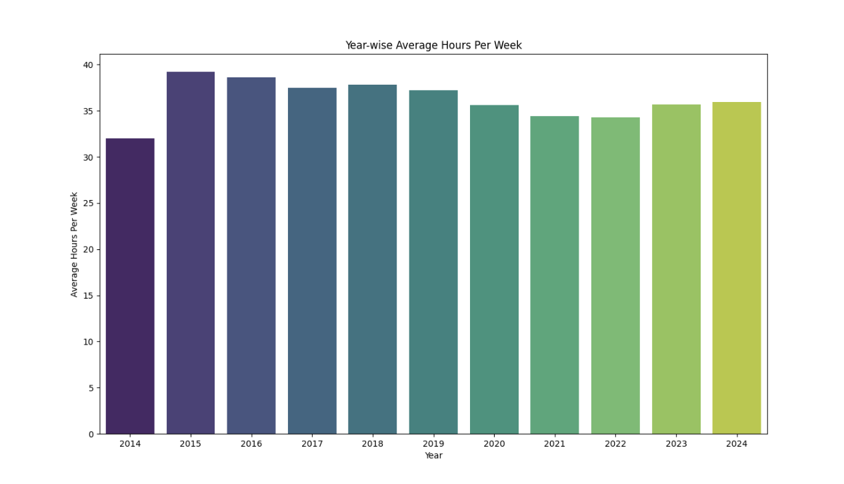

**Year-wise Achievement Count**

The count of achievements per year shows that there has been an increase in the number of achievements, reflecting a growing emphasis on acquiring certifications and skills.

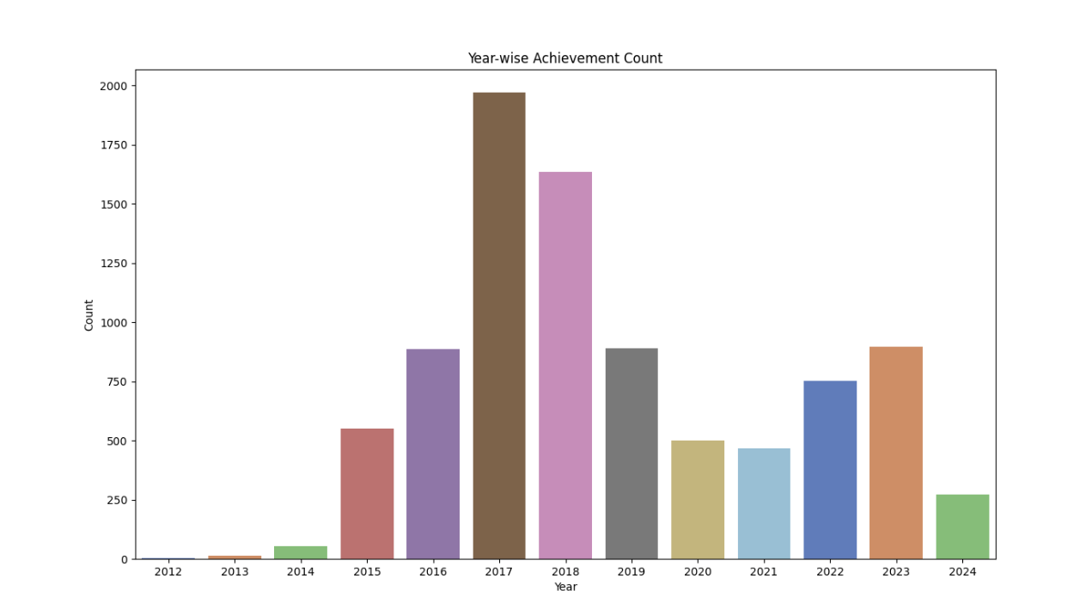

1. **Distribution of Starting Hourly Wage**
   * The distribution is skewed towards lower hourly wages, with a peak around the $15-$20 range. There are a few outliers with significantly higher wages.
2. **Boxplot of Hours Per Week by Placement Status**
   * The boxplot shows that 'Placed' individuals tend to work slightly more hours per week compared to 'Not Placed'. The distribution is wider for the 'Not Placed' group.

**Trend of Average Hours Per Week Over Years**

The line plot indicates that the average hours per week have slightly increased over the years.

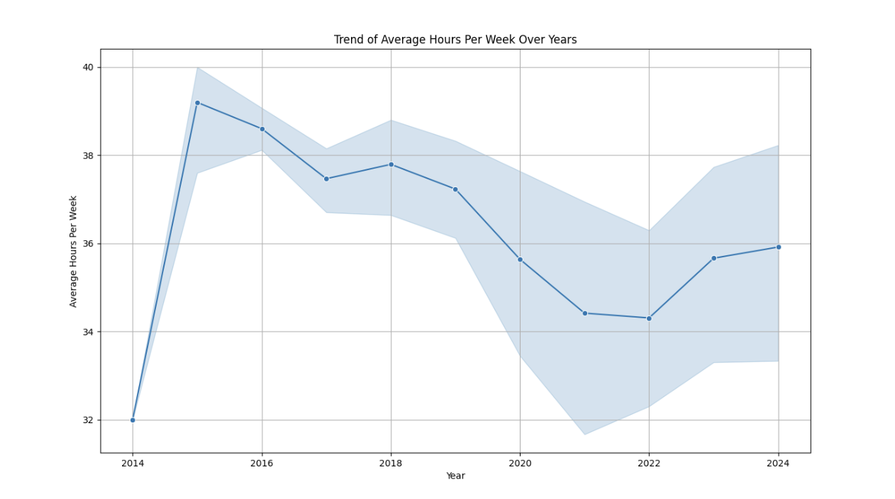

**Year-wise Availability of Benefits (Sick Leave, Vision Insurance, Health Insurance)**:

The line plot shows the count of job placements offering each benefit (sick leave, vision insurance, health insurance) over the years. It helps to understand how the availability of these benefits has evolved over time, indicating changes in employer-provided benefits.

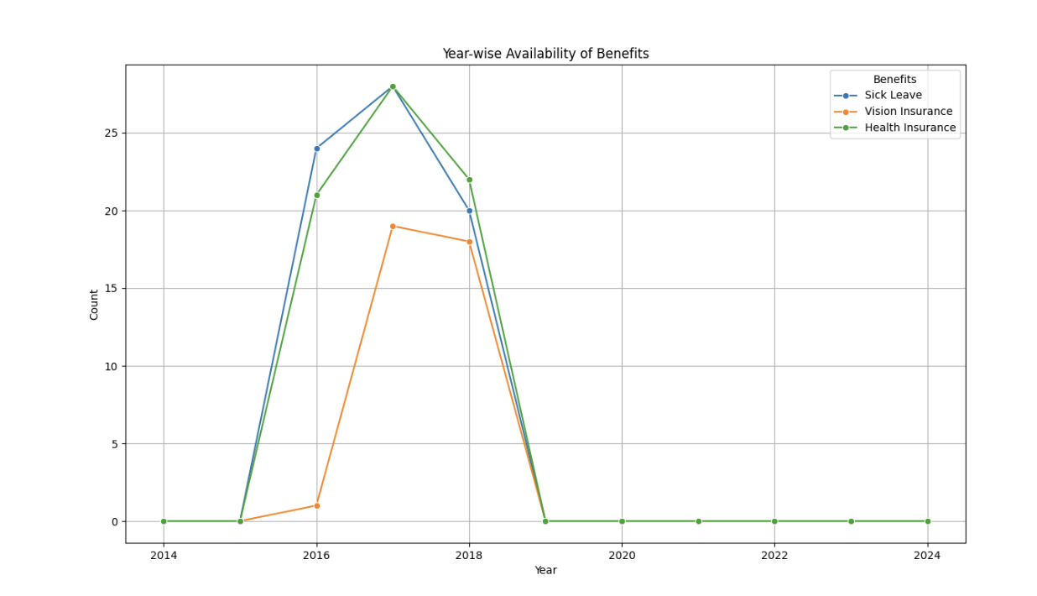

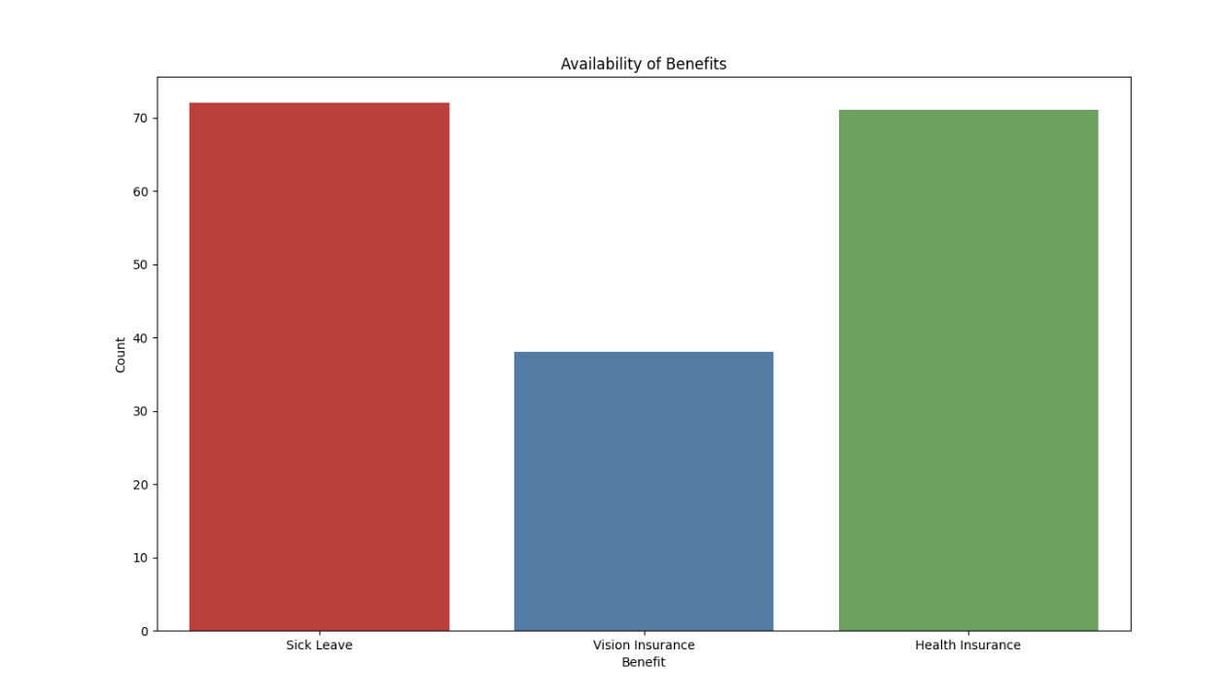

**Frequency of Placements at Different Worksites:**

The top 10 worksites by the number of placements were identified and visualized. This helps

in understanding which worksites have the most placements.

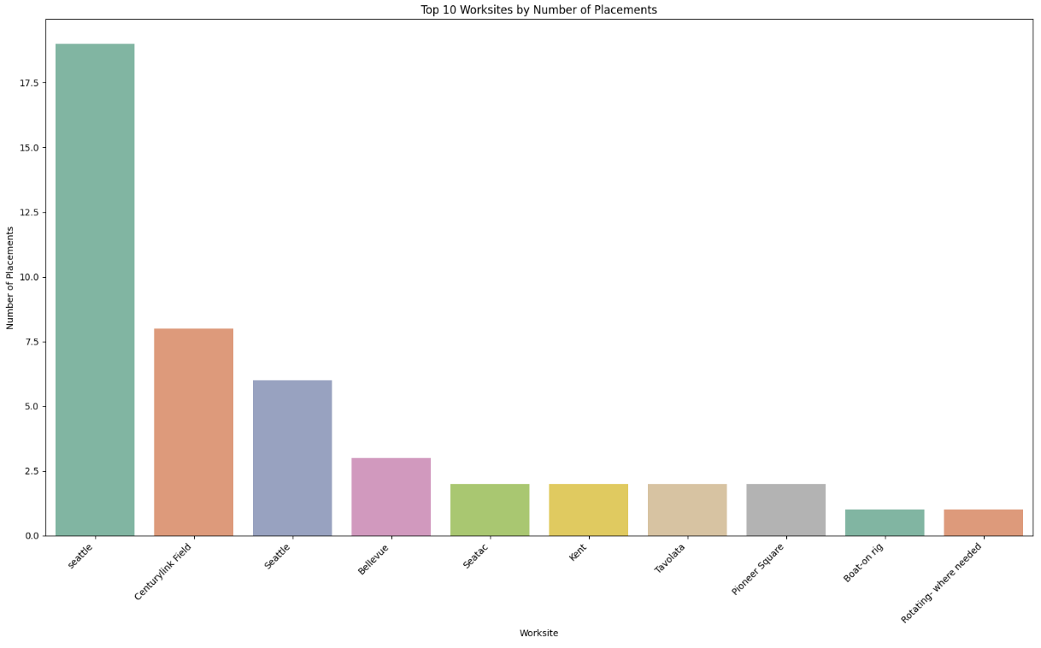

#### **Outcome Details Distribution**

Distribution of Outcome Details:

* The distribution of outcome details shows various reasons for job outcomes, with some outcomes more prevalent than others.

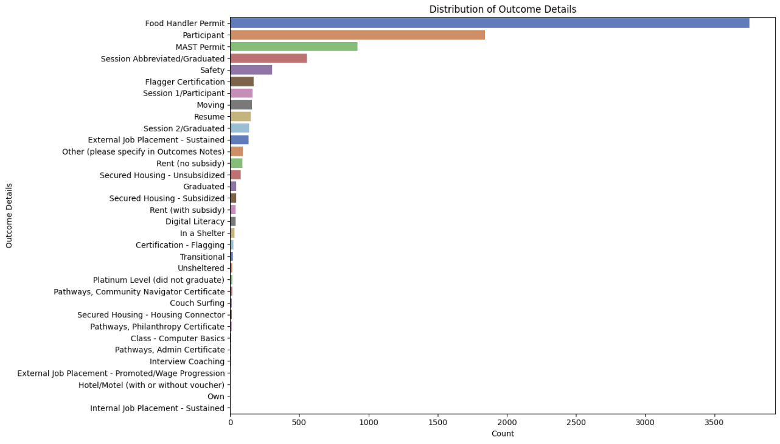

Year-wise Count of Outcome Details:

* There are variations in the outcome details over the years, indicating changes in job market conditions or company policies.

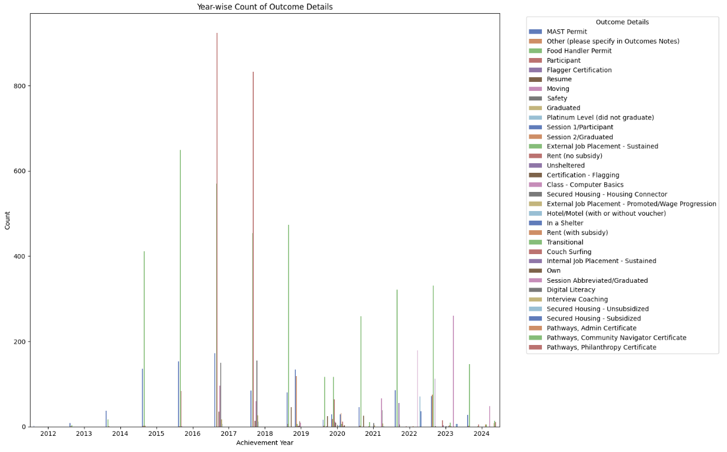

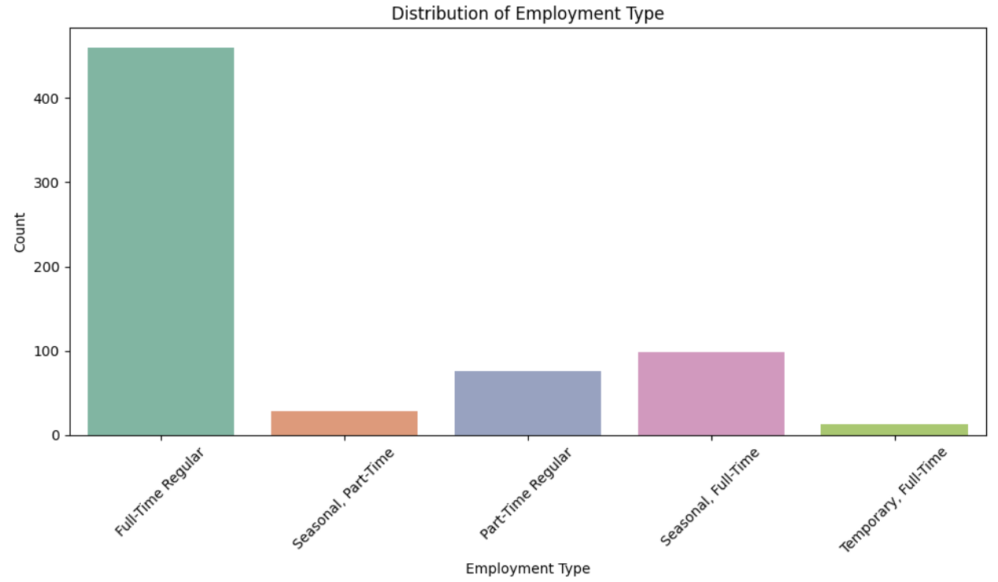

### **Furture Recommendations :-**

1. **Increase Certification Programs:** Since certifications positively correlate with higher starting wages and job placements, increasing the availability and diversity of certification programs can enhance job outcomes.
2. **Focus on Skill Development:** Emphasize skill development through platforms like Coursera and LinkedIn, as these have been shown to significantly impact placement success.
3. **Monitor and Support Working Hours:** Given that individuals who work more hours tend to have better placement outcomes, providing support and resources to manage and optimize working hours could be beneficial.
4. **Continuously Update Compensation Plans:** Regularly updating and reviewing starting wages to match industry trends can improve placement rates.